Development and Implementation of an Android To-Do List Application

Mark Hahn

Colorado State University Global Campus

CSC475

Professor Thakkar

8/9/24

Development and Implementation of an Android To-Do List Application

The primary objective of the To-Do List application is to provide users with a simple, intuitive platform to manage daily tasks effectively. By leveraging the MVVM architecture, the application ensures a clean separation of concerns, enhancing maintainability and scalability. This design pattern, along with SQLite for data persistence, offers a robust solution for managing tasks within the Android environment.

## Challenges Faced

The development process was not without challenges. Initially, the integration of Data Binding posed difficulties, leading to build errors and unresolved references. As an alternative, the MVVM pattern was implemented using ‘ViewModel’ and ‘LiveData’, which required a deep understanding of lifecycle management within Android applications Geeks for Geeks (2022). Additionally, configuring the build files to ensure compatibility between Kotlin and Java targets presented obstacles that were overcome by aligning the JVM target versions and ensuring correct dependency management.

## Skills Acquired

Through the development of this application, several key skills were acquired:

* MVVM Architecture: Understanding and implementing the MVVM design pattern facilitated a modular and testable codebase.
* Lifecycle Management: Mastering the Android lifecycle allowed for the effective use of ‘ViewModel’ and ‘LiveData’, ensuring that data persisted across configuration changes.
* Dependency Management: The process of resolving issues related to dependency conflicts and target compatibility deepened my knowledge of Gradle and Kotlin build scripts Voronov (2020).

**Screenshot**

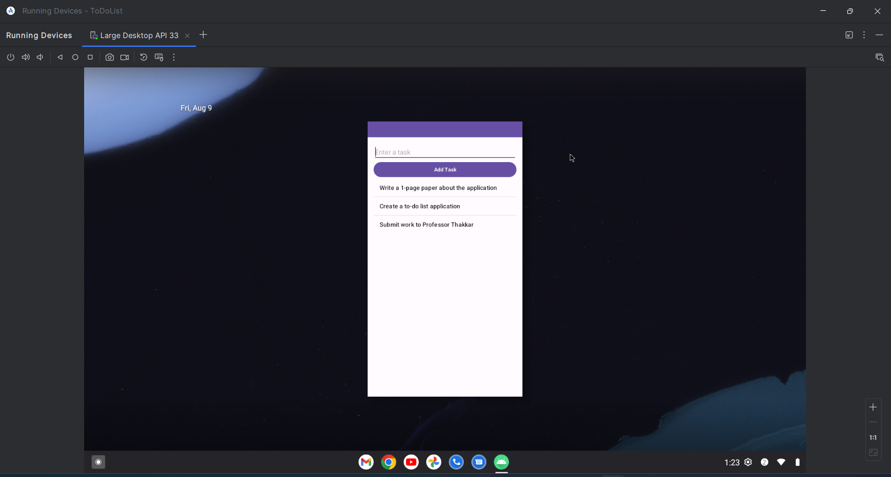

*Image of To-Do List application Running*

# Conclusion

The To-Do List application demonstrates the practical application of Android development concepts, particularly within the context of MVVM architecture. Overcoming the challenges faced during development led to a deeper understanding of Android's architecture components and enhanced my ability to manage dependencies and project configurations Android Developers (2023). The final product is a functional and maintainable application that meets the project's objectives.

# References

Geeks for Geeks. (2022). MVVM (Model View ViewModel) Architecture Pattern in Android. *GeeksforGeeks.org.* Retrieved from [MVVM (Model View ViewModel) Architecture Pattern in Android - GeeksforGeeks](https://www.geeksforgeeks.org/mvvm-model-view-viewmodel-architecture-pattern-in-android/)

Voronov, D. (2020). How to manage Gradle dependencies in an Android project properly. *Medium.com.* Retrieved from [How to manage Gradle dependencies in an Android project properly. | by Dmitriy Voronov | Doubletapp | Medium](https://medium.com/doubletapp/how-to-manage-gradle-dependencies-in-the-android-project-proper-way-dad51fd4fe7#:~:text=How%20to%20manage%20Gradle%20dependencies%20in%20an%20Android,repositories%20alongside%20dependencies%20...%206%206%29%20Kotlin%20DSL)

Android Developers. (2023). Guide to app architecture. *AndroidDevelopers.com.* Retrieved from [Guide to app architecture | Android Developers](https://developer.android.com/topic/architecture)